**Third task of Web and NLP**

**Picture of the web page:**

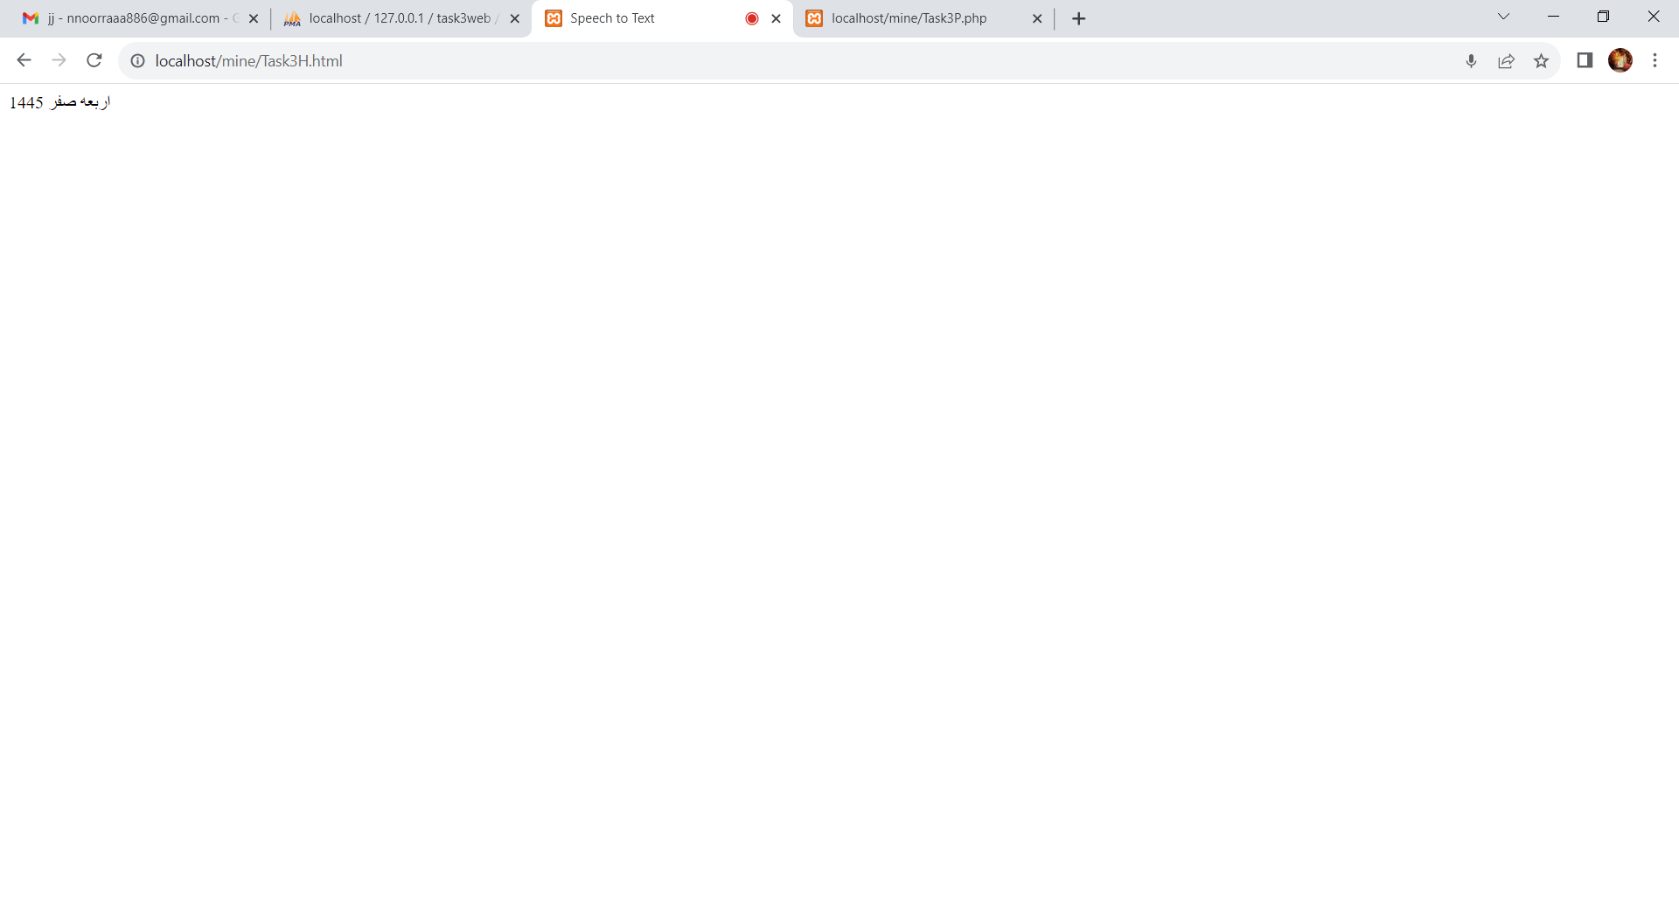

**Picture of the database:**

